Blockhouse work trial

***2024 papers***

1. ***Optimizing Broker Performance Evaluation through Intraday Modeling of Execution Cost***
   1. The paper offers a new way of calculating execution cost. Their linear cost is estimated as slippage to TWAP which is a relatively model free process. Their impact cost relies on sampling trade data during execution. I thought this was interesting because in the Almgren and Chriss (2000) paper, the authors discussed how it might be beneficial to observe impact during execution and adjust accordingly. As someone unfamiliar with this subject matter, figure one was very helpful in showing how the signal to noise ratio was reduced and the Brownian motion underlying the researcher’s model. This was a good way of showing how their contribution improved on existing modeling.

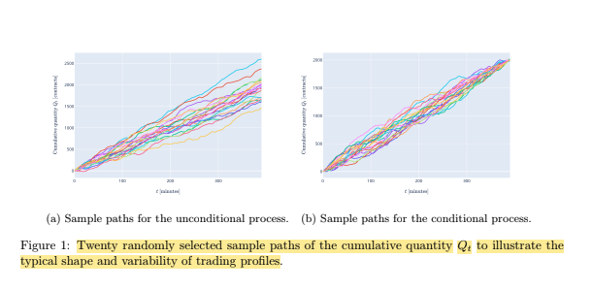

1. ***Do Price Trajectory Data increase the efficiency of market impact estimation?***
   1. Intuitively, early actions in trade execution will have greater impact than those later in the process. The authors walk through the development of trade execution models, starting with Almgren and Chriss and then working their way through second generation propagator models. Later, they model this intuitive feature of trade execution and explain some limitations to their model and ways to improve it for example using VWAP and assuming heavy tail distributions instead of gaussian for price movements. I also liked table 1 & figure one from this paper. The figure shows how the market impact is much higher during the early stages of the trade.

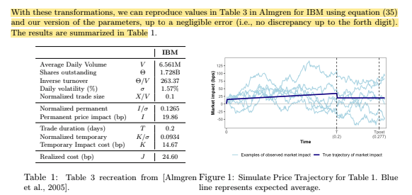

***Older Papers***

I am not the most familiar with the academic literature around trade execution. I wanted to go back to basics to understand some of the foundational papers before coding my models.

To that end, I read ***Optimal Execution of Portfolio Transactions by Almgren and Chriss***. I found this paper to be really interesting and accessible for someone who is not familiar with the subject matter. The concepts of temporary and permanent price impacts were really intuitive. Additionally, framing the execution strategy through risk aversion made a lot of sense to me. The ‘naive strategy’ of evenly executing small blocks of trades during the trading window would almost never be optimal because this is a risk neutral strategy. In practice investors are almost always risk averse. I like figure two in this paper. C would be a risk loving strategy. B is the risk Neutral ‘naïve strategy’ and somewhere around A would be optimal. We also see that the trade is front waited in terms of execution intuitively to reduce risk.

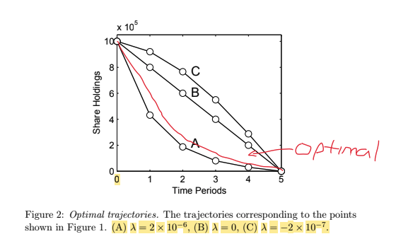

In another paper, ***Option Hedging with Smooth Market Impact***, Almgren and his coauthor focus further on market impact. Specifically, they note how option hedging around expiration dates for large-cap stocks can impact the market. For example, there was a ‘saw tooth’ pattern in the stock of coca cola which was probably caused by a ‘naïve’ hedging strategy executed by a large market participant.

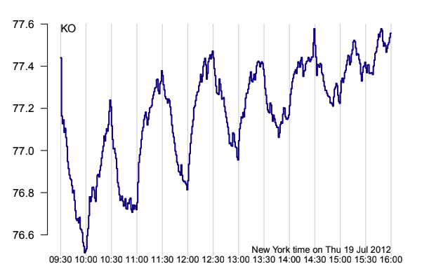

In contrast, the optimal strategy would be to trade more aggressively towards the early part of the trade window which would in turn smooth out the curve.